SOFTWARE TESTING (CSA37)
ASSIGNMENT 1 – CO1

Name : Lakshmipathi Deepthi
Reg no : 192411213

Evaluate the Quality Process and Defect Profile of a Grocery Delivery

Task 1 – Evaluate Testing as an Engineering Activity (5 Marks)
FreshCart’s testing cannot be considered a mature engineering activity if testing was performed only just before release, twenty scenarios were treated as sufficient proof, and no trained independent tester or systematic defect analysis existed. This approach relies on hope rather than planned quality engineering.
- A defined method was missing: engineering testing requires test planning, measurable objectives, risk analysis, traceability to requirements, and documented results.
- Quality was not built in early: requirement reviews, design reviews, coding standards, unit tests and integration tests can prevent or detect defects before release.
- Evidence was too weak: passing twenty scenarios shows only that those particular scenarios passed under their test conditions. It does not prove that all important workflows, edge cases, devices, payment states or delivery conditions work.
- Learning was limited: customer-care e-mails and a shared spreadsheet do not reliably link incidents to root causes, code changes, test cases and prevention actions.
Judgement: FreshCart mainly hoped for quality. It should move to risk-based, lifecycle-wide testing with defined entry/exit criteria, repeatable evidence and continuous improvement.

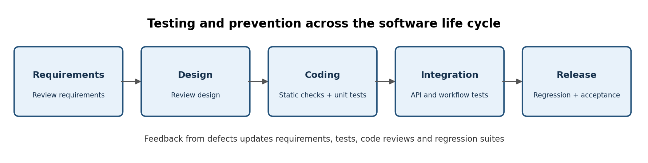

Task 2 – Evaluate the Role of Process in Software Quality (2 Marks)
Experienced developers are valuable, but quality cannot depend on individual skill alone. A good process makes good practices repeatable across the team, including when staff are busy or new.
- People contribute expertise and judgement; process ensures reviews, automated tests, clear acceptance criteria, defect tracking and release checks are consistently performed.
- A practical balance is to hire and train capable people while establishing lightweight standards and measurable quality gates. More developers without a process may simply produce defects faster.
Conclusion: Quality is a result of capable people working within an effective process, not people alone.

Task 3 – Evaluate Testing as a Process (6 Marks)
Testing should run from requirements through maintenance, rather than being a single pre-release event. Early activities include reviewing requirements and designs; coding adds static analysis and unit tests; integration adds API and workflow tests; release adds regression, usability, security and acceptance checks.
Illustrative calculation (because the supplied prompt contains no original defect counts): assume 10 defects are eventually reported after release. If 6 are detected before release, 4 escape. The escape rate is:
Defect escape rate = defects found after release ÷ total defects found = 4 ÷ (6 + 4) × 100 = 40%.
If lifecycle testing detects 8 of the same 10 defects before release, then 2 escape: 2 ÷ 10 × 100 = 20%. The escape rate falls by 20 percentage points, or 50% relative to the original 40% rate. These numbers illustrate the method; they are not FreshCart’s actual results.
Measure | Late-only testing (example) | Lifecycle testing (example)
Defects found before release | 6 | 8
Defects found after release | 4 | 2
Total known defects | 10 | 10
Escape rate | 40% | 20%
Interpretation | More customer-facing defects | Earlier detection; fewer escapes

Interpretation: earlier detection reduces rework because requirements, designs and code are cheaper to correct before release. FreshCart should collect actual counts by phase and calculate escape rate, detection phase, severity and re-open rate each release.

Task 4 – Apply and Critique Basic Definitions (4 Marks)
Term | Meaning | FreshCart example
Error | A human mistake made while understanding, designing or coding. | A developer misunderstands the rule for applying a delivery fee.
Defect (fault/bug) | A flaw in a requirement, design, code or configuration caused by an error. | The code calculates the delivery fee incorrectly.
Failure | Incorrect behaviour observed when the software runs. | The customer sees a wrong total at checkout.

Careless terminology harms quality because it hides the difference between a human cause, a flaw in an artefact and an observable impact. Without these distinctions, the team may fix the visible symptom but fail to correct the requirement, design or coding practice that caused it. Consistent definitions improve triage, root-cause analysis, metrics and communication with customer care.

Task 5 – Evaluate the Application of Testing Principles (3 Marks)
- Testing shows the presence of defects, not their absence: twenty passing scenarios cannot prove FreshCart is defect-free.
- Exhaustive testing is impossible: grocery delivery has many combinations of products, addresses, offers, payment states, stock changes, devices and network conditions.
- Early testing saves time and cost: waiting until release means requirement and design defects are discovered after dependent work has been completed.
- Defects cluster: if incidents concentrate around checkout, pricing or delivery integration, those areas need deeper testing rather than equal effort everywhere.
- Testing is context-dependent: a grocery application needs strong coverage of cart totals, stock, payment, delivery address/location and order status.
- The absence-of-errors fallacy: software that passes tests is still unsuccessful if it does not meet customer needs, such as clear delivery updates and accurate order fulfilment.
Therefore, the team’s claim is not justified. Release readiness must be based on risk coverage, critical-path results, severity thresholds and agreed acceptance criteria.

Task 6 – Evaluate the Tester’s Role (3 Marks)
A trained, independent tester would likely have improved the outcome, but could not guarantee that every defect would be found. Developers may test their own assumptions and overlook scenarios that contradict their mental model. An independent tester can challenge requirements, explore unusual paths and report evidence objectively.
- Training improves test design: equivalence partitions, boundary values, negative tests, exploratory testing and risk-based prioritisation.
- Independence improves challenge and reporting: testers can question whether twenty scenarios represent real customer risks.
- The role must be supported by developers: code reviews, unit tests and fixes remain the whole team’s responsibility.
Conclusion: a trained tester could reduce escaped defects, especially when combined with lifecycle testing and automation; the same defects are not inevitable.

Task 7 – Trace the Origins of Defects (4 Marks)
The ten incident descriptions were not included in the prompt, so individual incidents cannot be traced reliably without inventing facts. Use the following lifecycle mapping for each incident in the original case sheet:
Possible origin | Evidence to inspect | Prevention/control
Requirements | Ambiguous fee, refund, stock or location rules | Acceptance criteria, examples, stakeholder review
Design | Missing states, weak error handling or unclear interfaces | Architecture/design review, sequence diagrams
Coding | Wrong conditions, calculations or validation | Unit tests, static analysis, peer review
Integration | Incorrect API contract, timeout or duplicate request handling | Contract tests, integration tests, retry/idempotency tests
Test process | Important path omitted or expected result wrong | Traceability, risk-based test design, independent review
Release/configuration | Wrong environment, secrets, feature flags or settings | Deployment checklist, configuration validation, rollback test
Operations/monitoring | Failure not detected or customer impact not contained | Logs, alerts, dashboards and incident review

For each of the ten incidents, record the customer-visible failure, the defect in the product, the earliest phase where it could have been detected, the actual origin confirmed by evidence, and the prevention action. The phase where a defect is discovered is not necessarily the phase where it originated.

Task 8 – Evaluate Defect Classes and Severity (4 Marks)
Severity describes the impact of a defect; priority describes how urgently the team should fix it. They are related but not identical. A rare privacy leak may be high severity even if it affects few users; a minor text issue may have low severity but high priority before a public campaign.
Because the actual ten incident descriptions were not supplied, the table below is an illustrative template with ten common grocery-app incidents. Replace any row that does not match the case handout.

# | Incident (illustrative) | Class | Severity | Priority | Justification
1 | Incorrect cart/order total | Functional / calculation | Critical | P1 | Customers may be overcharged; financial and trust impact.
2 | Payment succeeds but order is not created | Integration / transaction | Critical | P1 | Money/order mismatch requires urgent containment and reconciliation.
3 | Duplicate order after retry | Integration / idempotency | High | P1 | Customer may be charged or receive duplicate deliveries.
4 | Out-of-stock item still purchasable | Data / business rule | High | P1 | Promised items cannot be fulfilled; substitutions/refunds required.
5 | Wrong delivery address selected | Functional / location | Critical | P1 | Order may go to the wrong home; safety and privacy concern.
6 | Order status does not refresh | Functional / state update | Medium | P2 | Creates confusion and increases support calls.
7 | Offer code rejected despite eligibility | Business rule | Medium | P2 | Customer loses expected discount; revenue/trust impact.
8 | App crashes on older device | Compatibility / reliability | High | P1/P2 | Blocks affected customers from ordering.
9 | Small text or misaligned button | Usability / UI | Low | P3 | Reduces usability but usually has a workaround.
10 | Customer location shared without proper consent | Security / privacy | Critical | P1 | Sensitive location exposure and legal/reputational risk.

Priority guide: P1 = immediate fix or mitigation before further release; P2 = fix in the next planned release; P3 = schedule when capacity permits. The team should prioritise payment, order integrity, wrong-address and privacy risks above cosmetic issues. Final ratings must follow FreshCart’s actual incident evidence and impact.
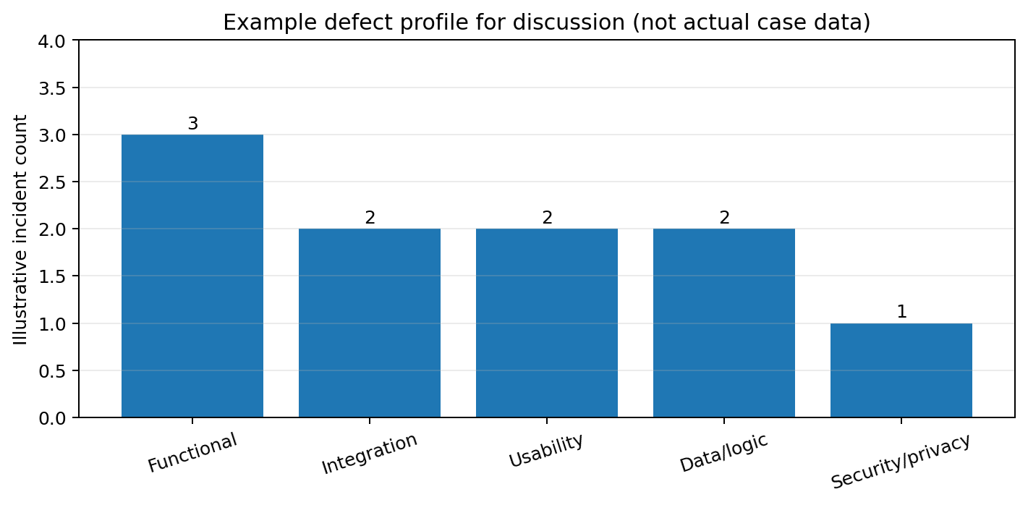
The chart is illustrative only; it is not a measured distribution of FreshCart’s actual incidents.

Task 9 – Design and Appraise a Defect Repository (3 Marks)
FreshCart should use one searchable defect repository rather than relying on separate e-mails and a spreadsheet. Each record should contain:
- Unique defect ID, short title, description, date reported, reporter and affected app/version/device.
- Reproduction steps, preconditions, test data, expected result, actual result, screenshots/logs and frequency.
- Defect class, severity, priority, status, owner, target release, related requirement/user story and linked test case.
- Root cause, phase introduced, phase detected, workaround, fix commit/build, retest result and regression test.
- Customer impact, duplicate links, timestamps, closure reason and prevention action.
The repository supports trends such as escaped defects by release, common root causes, time to fix and re-open rate. Access controls and privacy rules are necessary: do not store real payment credentials or unnecessary customer location data in defect attachments.

Task 10 – Evaluate Defect Examples and Prevention Strategies (4 Marks)
Example defect class | Single process change | Cost/effort | Benefit | Value judgement
Calculation/business rule (e.g., wrong total) | Review acceptance criteria with worked examples and add unit tests for totals, discounts and delivery fees. | Low–medium initial effort; tests are reusable. | Prevents repeated pricing mistakes and protects revenue/trust. | Very high value because it is cheap and repeatable.
Integration/transaction (e.g., payment/order mismatch) | Add automated API contract and end-to-end tests for success, failure, timeout and retry paths. | Medium effort; needs test environment/provider simulation. | Catches broken hand-offs and duplicate/partial transactions. | High value due to financial and operational risk.
Privacy/location (e.g., location shared improperly) | Add a privacy/security review and consent/permission tests to the definition of done. | Low–medium effort; requires specialist review for high-risk changes. | Reduces exposure, compliance risk and reputational harm. | Very high value because potential impact is severe.

Best value: worked examples plus automated unit tests are often the quickest high-return starting point, while privacy and payment controls are non-negotiable because of their potential impact. The best overall portfolio combines low-cost prevention with risk-focused integration and security testing.
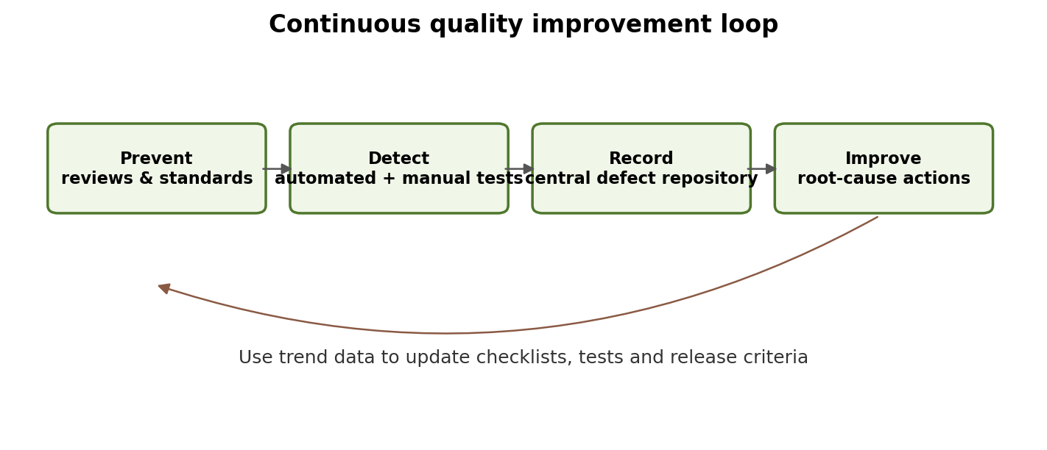

Task 11 – Recommend and Defend a Quality Improvement Plan (4 Marks)
FreshCart can adopt the following plan without creating a large separate quality department. With six developers, quality activities should be shared and lightweight, with one person coordinating testing for each sprint.
When | Action | Owner/evidence | Reason
Immediately | Triage all open incidents; mitigate P1 payment, order, address and privacy risks. | Team lead + developer; prioritised defect list. | Protects customers first.
Every requirement/change | Write testable acceptance criteria and review high-risk requirements/designs. | Product owner + developer + tester; reviewed stories. | Prevents ambiguity early.
Every code change | Peer review, unit tests and static checks; block merge on failure. | Author + reviewer; CI result. | Finds defects cheaply before integration.
Every build | Run automated API, integration and critical user-journey regression tests. | Rotating test owner; test report. | Prevents repeated failures.
Before release | Check critical workflows, accessibility/usability, security/privacy and rollback readiness. | Independent review/rotating tester; release checklist. | Provides evidence-based release decision.
After each incident | Record root cause, link fix to regression test, review trends monthly. | Defect owner; repository metrics. | Stops recurrence and supports improvement.

Expected effect: fewer escaped high-impact defects, earlier discovery, more repeatable releases, clearer accountability and better evidence for release decisions. Risks include slower delivery during initial test creation, flaky automation, and treating metrics as targets rather than learning tools. Reduce these risks by starting with critical paths, maintaining tests, reviewing flaky failures and expanding gradually.
Practicality: this is realistic for six developers if testing is part of normal development rather than a final hand-off. One developer can coordinate testing each sprint while others own unit tests, reviews and fixes. For high-risk payment/privacy changes, obtain a specialist review when needed.

Task 12 – Re-evaluate and Adapt the Quality Process (Day-4 Design Challenge) (8 Marks)
Decision: MODIFY the original plan and redesign selected controls. The lifecycle-wide, risk-based foundation remains useful, but weekly releases and external data-sharing integrations require faster automation, stronger interface testing, and explicit privacy/security gates.

A. Impact Analysis (2 marks)
- Weekly releases reduce the time available for manual regression. Repeating the full test suite by hand becomes slow and inconsistent; automated smoke and critical-path regression tests are necessary.
- External UPI introduces provider outages, timeouts, delayed callbacks, duplicate notifications, failed payments and reconciliation risks. Tests must cover idempotency, signature/response validation, refunds and order/payment state consistency.
- Sharing live location with a third party introduces consent, purpose limitation, access control, retention, transmission security and revocation risks. Incorrect sharing can expose a customer’s movements.
- More frequent releases increase change-related risk, so monitoring, staged rollout and rollback become more important.

B. Evaluation of the Original Plan (2 marks)
- Retain: lifecycle testing, peer reviews, defect repository, root-cause analysis, risk-based priorities and clear severity/priority definitions.
- Modify: replace a mainly manual release checklist with a CI/CD quality gate; run unit tests on every change and integration/regression tests on each build; keep manual exploratory testing for new or complex behaviour.
- Strengthen: add UPI sandbox/contract tests, simulated timeouts and duplicate callbacks, privacy threat modelling, consent-flow tests and checks that location access stops when permission is withdrawn.
- Do not rely only on a tester’s final approval. Quality gates should be automated where possible and owned by the whole team.

C. Adaptation or Redesign (2 marks)
Control | Weekly-release adaptation
Continuous integration | Every pull request runs formatting/static analysis, unit tests and build checks; failed checks block merge.
Automated regression | Prioritise login, search, cart, price, checkout, payment result, order creation, delivery address and status.
UPI integration | Use provider sandbox and contract tests; test success/failure/pending, timeout, callback duplication, invalid response, refund and reconciliation.
Location privacy | Obtain clear consent; share only necessary location and only for the required delivery purpose/time; secure APIs, limit access and log access safely.
Release strategy | Use staged/canary rollout where feasible, health checks, monitoring, feature flags and a tested rollback plan.
Defect learning | Track escaped defects, P1 incidents, test duration, flaky-test rate and mean time to restore; review after each release.

D. Evidence-Based Defence (2 marks)
The redesign is justified because release frequency makes repeatable automated checks more efficient than manual-only testing, while external payment and location integrations create risks that ordinary UI scenarios may not cover. The team should compare at least four weeks of baseline data with later releases:
- Defect escape rate = post-release defects ÷ all known defects × 100.
- Critical-path pass rate = passed critical automated tests ÷ total critical automated tests × 100.
- Change failure rate = releases causing incidents/rollback ÷ total releases × 100.
- Mean time to restore (MTTR) = total time to restore service ÷ number of incidents.
A successful adaptation should reduce high-severity escaped defects and change failure rate without making the pipeline so slow that weekly delivery becomes impractical. Targets should be set after measuring a baseline, not invented in advance. For six developers, the plan is feasible if automation is incremental, test ownership rotates, and specialist support is used for high-risk payment/privacy reviews.

Overall Conclusion
FreshCart’s central problem is not simply a lack of effort; it is a weak quality process. Testing must be planned, risk-based, repeatable and continuous from requirements to production. A central defect repository, trained testing skills, reviews, automation and root-cause prevention will turn customer complaints into evidence for improvement. For weekly releases, payment-provider integration and third-party location sharing, the same foundation should be strengthened with CI/CD quality gates, transaction-state testing, privacy controls, monitoring and rollback readiness.

References
- ISTQB, Certified Tester Foundation Level (CTFL) Syllabus – testing principles, test activities, defect management and test levels.
- ISO/IEC 25010, Systems and software Quality Requirements and Evaluation (SQuaRE) – product quality model.
- OWASP Application Security Verification Standard (ASVS) and OWASP API Security guidance – application/API security testing.
- Google Cloud, DORA metrics guidance – change failure rate and recovery measurement.

